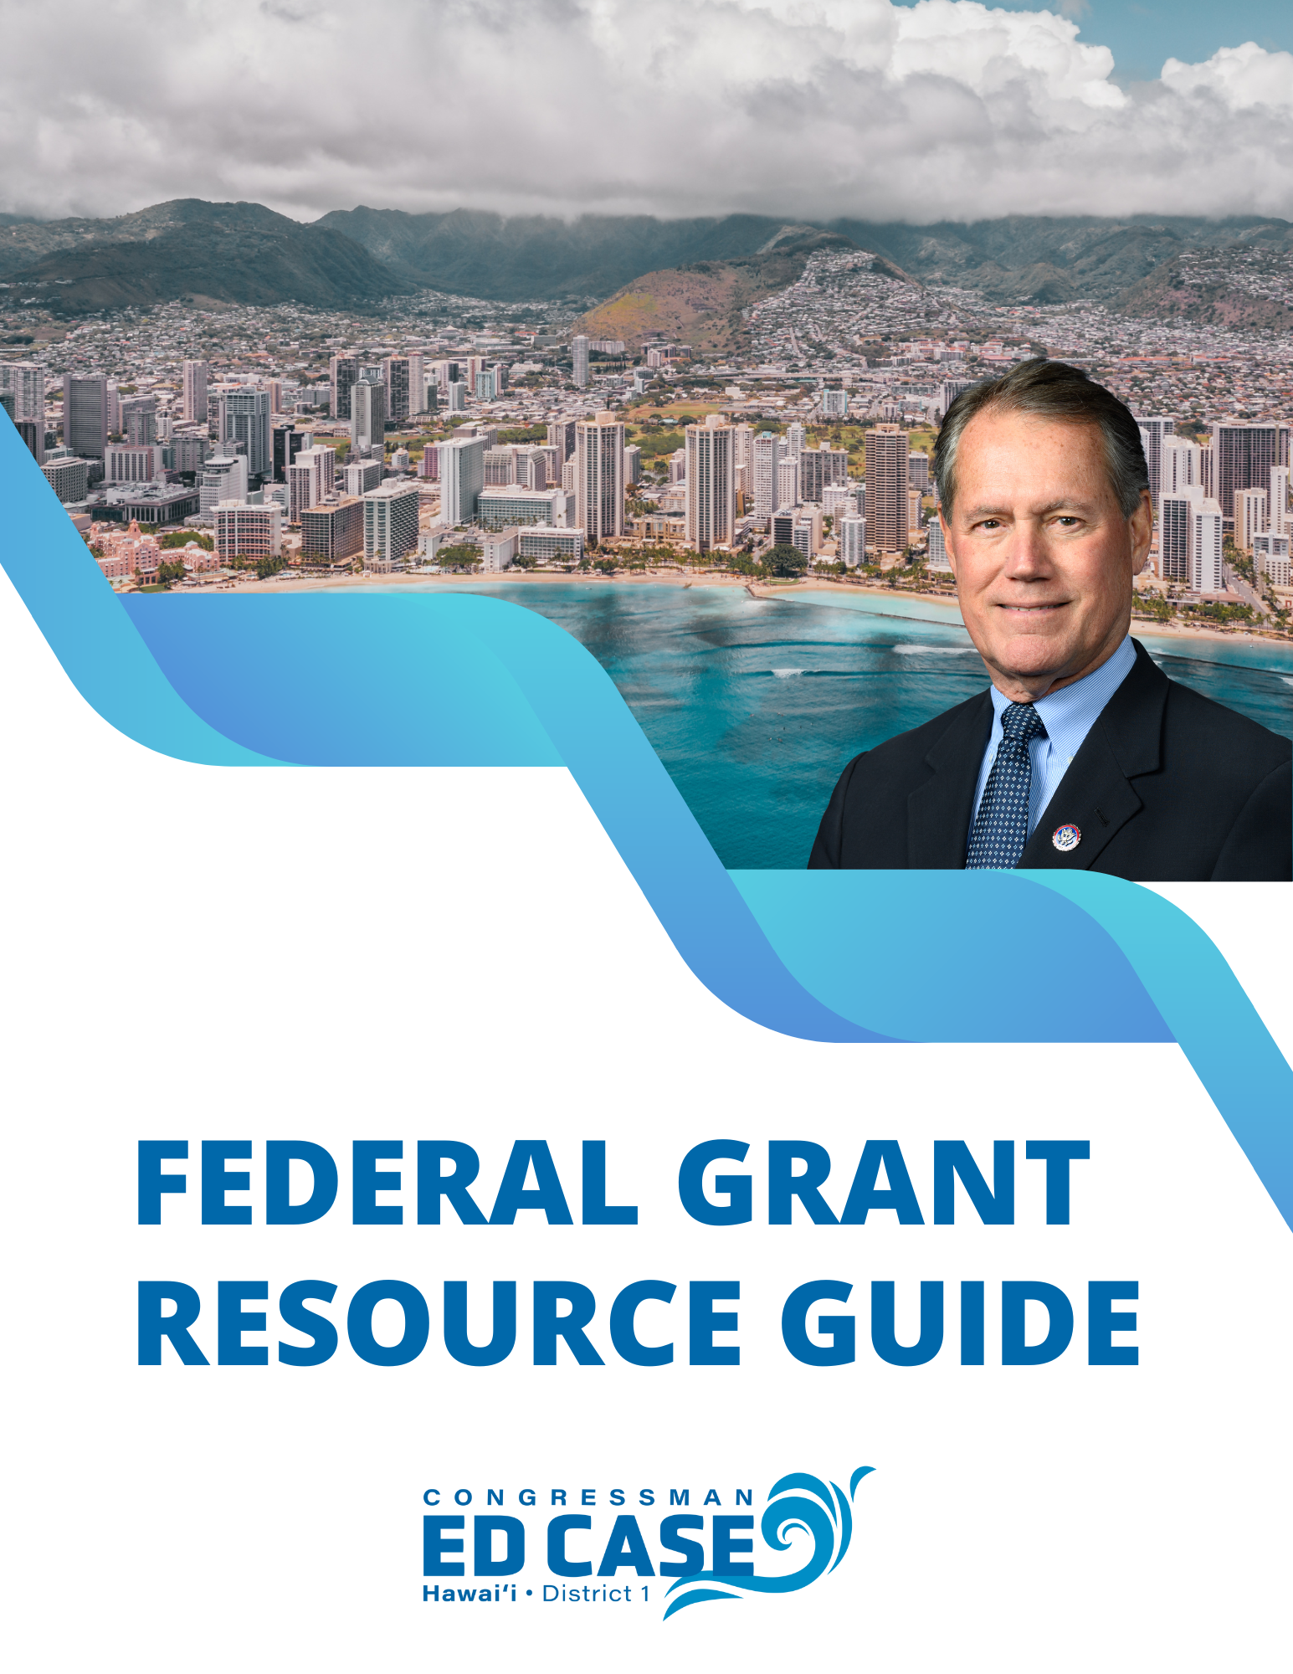

Updated Jan. 2025

**a message from congressman ed case**

Aloha!

One of my top priorities as Hawaii’s U.S. Representative is to assist our state and local governments, educational institutions, non-government organizations (mainly non-profits) and others to secure federal funding support for your efforts. I use a number of resources to do so, especially my membership on our U.S. House Committee on Appropriations, responsible for all federal discretionary spending (all spending other than mandatory programs like Social Security and veterans benefits).

Federal funding support comes mainly from three sources: (1) specified funding of federal programs by Congress through our annual appropriations process; (2) funding of specific community projects by Congress through our annual appropriations process (Community Project Funding, or “CPF”); and (3) funding by the federal executive branch (the departments and agencies) through grants of funds appropriated by Congress.

In this Federal Grants Resource Guide, I’m just focusing on the last of these sources: federal grants. But you should also review the CPF and other specific funding possibilities through my Appropriations Committee. More information on these possible sources of federal funding support is on my website at <https://case.house.gov/services/appropriations-requests.htm>.

This guide explains the federal grants process. It will help you search for grant opportunities, learn how to submit a grant request, and find additional potential funding resources.

My staff and I are here to support you in your search, your application and your further efforts to secure federal grant funding. Some of the specific ways in which we can assist are outlined in this guide.

If you have questions or need assistance, please don’t hesitate to contact us at (808) 650-6688 or [ed.case@mail.house.gov](mailto:ed.case@mail.house.gov). We are here to help and look forward to working with you.

With aloha,



U.S. Congressman Ed Case

Hawai‘i-First District

**INDEX**

An Overview of Federal Grant Funding – 4

Determining Eligibility – 4

Searching for an Appropriate Grant – 5

Developing and Submitting Funding Proposals – 7

Obtaining Letters of Support – 8

Tracking Your Application – 8

Managing Your Award– 9

Application Checklist – 9

**STAY CONNECTED**

Please stay connected with my office through my website and social media platforms:



* Case.house.gov



* Facebook.com/RepEdCase



* Instagram.com/RepEdCase



* x.com/RepEdCase



* Youtube.com/RepEdCase

**An Overview of Federal Grant Funding**

Applying for federal grants can at first be complex and time-consuming, but is usually far more than worth the effort.

To simplify the process, you must first understand the steps to identify funding opportunities and submit and pursue a grant application. This guide explains the process and provides you with the tools necessary to develop and pursue a competitive application, in particular, to:

1. Determine the type of federal funding for which your organization may qualify
2. Search for and identify grant opportunities
3. Develop and submit a grant proposal
4. Obtain letters of support
5. Track your application
6. Manage your grant

Many of our federal assistance programs have both seen reduced overall funding and increased competition over the last few years. That said, I have seen and assisted with many Hawai‘i federal grant applications that have been and continue to be awarded, and there is every reason to conclude that a well-developed and supported Hawai‘i application will be strongly considered.

For starters, I strongly encourage you to start your search early and adhere closely to all application deadlines. Identifying funding opportunities that align with your needs can be a time-intensive process, and you must also remember that every organization has its own unique objectives and goals, which is why it’s essential for grant seekers to personally conduct thorough research to ensure no critical funding opportunities or application steps are missed.

It’s also more important than ever to submit grant proposals that make your organization stand out in a competitive pool of applicants. Crafting a compelling application requires effort but can be well worth it, especially as our Hawai‘i is unique in many areas.

That’s why I urge you to take full advantage of the resources available during the application process. For example, consider contacting colleagues with experience drafting grant applications or consulting with local organizations specializing in developing strong proposals. Many of the federal government entities that consider grants make staff and other resources available to help applicants through the process.

**Determining Eligibility**

One of the most basic questions at the beginning of your search is determining if the person or entity seeking the grant is eligible for the grant to start with. In general, individuals and businesses are not eligible for federal grants; grantees must be formal organizations. Here are the most common grant applicants:

* Government Organizations
  + State Government (and its departments and agencies)
  + City and County Government (and its departments and agencies)
  + Special Government Organizations (such as the Office of Hawaiian Affairs)
* Education Organizations
  + Public and State-Controlled Institutions of Higher Education
  + Private Institutions of Higher Education
  + Public Schools
* Government Public Housing Organizations
  + Public Housing Authorities
  + Department of Hawaiian Home Lands
* Non-Profit Organizations
  + Nonprofits having a 501(c)(3) status with the Internal Revenue Service
  + Nonprofits that do not have a 501(c)(3) status with the Internal Revenue Service
  + Native Hawaiian Organizations
* For-Profit Organizations

Identifying which category your organization falls into is an important step that can simplify your grant search. For example, local governments and not-for-profits often do not qualify for the same grant opportunities. In some cases, your organization may qualify under multiple categories, broadening the range of funding opportunities available to you.

If you're unsure about your eligibility, please visit the following website for guidance: <https://www.grants.gov/applicants/applicant-eligibility>.

Again, federal grants for individuals (including students) and small businesses are very limited at the federal level. However, many other federal programs are specifically designed to provide tailored support. For example, the Small Business Administration has many programs focused on helping small businesses. My office can help identify and pursue these additional resources.

**Searching for an Appropriate Grant**

After determining eligibility, the specific grant search can begin.

In recent years, the federal funding process has become more streamlined, and most funding opportunities can be found centralized and online at the System for Award Management (SAM) ([www.SAM.gov](http://www.SAM.gov)) or [www.Grants.gov](http://www.Grants.gov). These websites serve as databases of current federal grant opportunities, and they are updated daily with new grant opportunities.

**Grants.gov.** Once grantseekers identify potential federal programs on SAM.gov or other federal websites, they may be directed to apply through [Grants.gov](http://www.grants.gov/). When competitive grant opportunities are announced, most federal agencies require grant applications to be submitted through [www.Grants.gov](http://www.Grants.gov). This website enables users to register, access applications and apply for funding from across 26 federal grant-making agencies. Through this site, grantseekers can monitor funding announcements, sign up for email notifications and submit applications online through a streamlined process.

Additionally, [Grants.gov](http://www.grants.gov/) provides guidance for registering with SAM, a required step for all federal grant applicants. For detailed registration instructions, visit [https://www.grants.gov/ applicants/applicant-registration](https://www.grants.gov/%20applicants/applicant-registration).

While the amount of information on the site may seem overwhelming at first, [Grants.gov](http://www.grants.gov/) offers a user-friendly interface that simplifies the process. [Grants.gov](http://www.grants.gov/) provides step-by-step tutorials for each stage of the process under the “Applicants” tab on its website. The registration process also involves registering with SAM.gov to obtain a Unique Entity Identifier (UEI). The UEI is a 12-character alphanumeric identifier assigned to all entities (public and private companies, individuals, institutions or organizations) to do business with the Federal Government. Organizations will also need to designate an E-Business Point of Contact. It can take 7 to 10 business days to fully complete the registration process required for most funding opportunities. There is no fee for registering with [SAM.gov](http://www.SAM.gov).

Sign up for a free account at [Grants.gov](http://www.grants.gov) so you can access useful features.

**SAM.** The General Services Administration (GSA) administers SAM. The website serves as the central hub for federal assistance listings, previously hosted on the Catalog of Federal Domestic Assistance (CFDA) website. On the SAM website, you can find official descriptions of more than 2,200 federal assistance programs (including grants, loans and other financial and nonfinancial assistance). Each federal assistance program has a corresponding CFDA program number used as numerical program identifiers.

Programs are searchable in the “Assistance Listings” section at SAM.gov here: [https://sam.gov/ assistance-listings](https://sam.gov/%20assistance-listings). The SAM website allows you to search for programs and access detailed descriptions, which are regularly updated by federal departments and agencies. These descriptions include essential information on authorizing legislation, program objectives, eligibility requirements and compliance guidelines. I encourage you to explore [SAM.gov](http://www.SAM.gov) to identify programs that align with your needs and goals.

**Private Opportunities.** In addition to federal grants, you can also consider searching for grants through the following non-federal sources:

1. *Foundation Center*. The center’s website (<https://candid.org/find-us>) is a gateway to information about private funding sources, the grant-seeking process, guidelines on writing a grant proposal, state libraries with grants reference collections and links to other useful websites. The center also offers a variety of training and educational seminars.
2. *Grantsmanship Center*. This organization (<https://www.tgci.com/funding-sources/hawaii>) links to Hawaii’s foundations, national community foundations and corporate giving programs.
3. *Council on Foundations*. The Council on Foundations’ website (<https://cof.org/member-directory/non-members>) has a list of the more than 750 community foundations throughout the nation and many in Hawai‘i that award grants.

**Developing and Submitting Funding Proposals**

Once you identify an appropriate grant you want to secure, it’s time to begin drafting your application.

You first need to carefully review the Funding Opportunity Announcement (FOA) or the Notice of Funding Opportunity (NOFO). The FOA/NOFO contains all the pertinent information and requirements for applicants to assess their eligibility and interest in the program. It will include the deadline for submitting applications and outline the various administrative steps you need to take. Reviewing the requirements outlined for each application is crucial, as these can vary considerably between programs.

A successful grant proposal is one that is well-prepared, thoughtful and concisely packaged. Each proposal should thoroughly explain why your organization requires the grant, how your organization will utilize awarded funds and what makes your organization deserving of assistance. A proposal should be neat, organized and void of any spelling or grammatical errors. It is highly recommended that several people review your application before submission.

Although you need to carefully review the specific requirements for the grant you are seeking, the basic sections of a standard grant proposal include the following:

1. Cover letter
2. Proposal summary
3. Description of the grant seeker or organization
4. Explanation of the local problem the grant will solve and why it will do so
5. Project objectives
6. Methods the project will use to solve the problem
7. Explanation of how the project’s performance will be evaluated
8. A budget
9. Other supplemental materials (such as surveys, data, etc.)

Each of these elements is described in detail in the Congressional Research Service report posted on my website at <https://case.house.gov/services/grant-applicants.htm>.

If you are applying for funding directly through a federal agency, it is helpful to reach out to that program’s point of contact as early as possible. This is usually listed on the FOA/NOFO but it is sometimes necessary to look at the agency’s website for this information. A federal point of contact often has in-depth knowledge of the program you are targeting. A federal employee can offer pertinent information regarding deadlines and the processes employed by the agency for accepting and reviewing applications.

If you do not have any prior grant proposal writing experience, it is also helpful to attend a grant writing workshop to ensure you are submitting a competitive application.

**Obtaining Letters of Support**

Community support is essential to securing a grant, and letters of support are often part of funding application requirements. Once you have developed a proposal summary, you should identify individuals or groups representing professional, academic, political and community organizations that may be willing to support your proposal in writing. The type and caliber of community support you can display through these letters can establish your credibility, which plays a critical role in the initial and subsequent review phases.

If you would like my office to consider a letter of support, requests should be submitted as early as possible and include the following information:

1. The name and description of your organization,
2. A detailed summary of your grant proposal,
3. The name and contact information for the head of the granting agency or program, and
4. A sample letter of support

While my office is not involved in the final selection of federal grant awards, I do consider providing letters of support when appropriate. To request a letter of support, please call my Honolulu District Office at (808) 650-6688 or email me at [ed.case@mail.house.gov](mailto:ed.case@mail.house.gov). You may also complete the Help With Your Concerns Form on my office’s website here: https:// [case.house.gov/forms/casework/](https://case.house.gov/forms/casework/).

When requesting a letter of support from my office, please provide my staff with a sample letter of support that includes relevant background information for your organization, a concise description of how this funding will help your organization and the community as a whole, and any other final letters of support. Please submit your requests for letters of support to my office at least two weeks before the application is due. If you require a letter of support and are closing in on a deadline, please call my staff to notify them of the impending deadline.

**Tracking Your Application**

After you submit your application, it enters the “review process.” The federal agency takes the following steps during this phase:

1. An initial screening is conducted to ensure the application is complete,
2. Applications are reviewed and assessed for substance,
3. A financial review of the applicant’s proposed budget is completed, and
4. Decisions are made and the awards are announced

If you have submitted your application through [Grants.gov](http://www.grants.gov/), you will be able to track its progress through the review process on the website.

**Managing Your Award**

When the federal government’s application review process is completed and a positive decision is made, the “award phase” begins. The awarding agency sends every winning applicant a Notice of Award (NOA). The NOA is an official, legally binding issuance of an award. When you or your organization accepts the award, you become legally obligated to carry out the full terms and conditions of the grant.

The “post award phase” is when the grant funds are disbursed and used to provide assistance to the community. During this phase, you will be asked to report your progress to the awarding agency. The federal agency that issues the award will assist you to ensure that your organization complies with the terms and conditions of the grant. The reporting requirements and implementation schedules vary for each grant, so it is important to review the award terms and conditions carefully for this information. While most award recipients implement funding ethically and efficiently, measures taken to monitor this process are necessary to maintain transparency and prevent fraud and abuse.

When the term of performance for a grant ends, the grant enters the “closeout phase.” To complete a closeout, you must submit final financial and programmatic reports with information requested by the awarding agency. All required financial and performance reports must typically be submitted within 90 days after the grant award expires. This process can take several months, and you are typically required to retain your grant records for at least three years from the date of the final expenditure report.

**Application Checklist**

As a summary, here’s a short checklist to help you navigate the process

Determine your eligibility for funding by identifying the type of organization you represent. If you are unsure of your eligibility, it can be checked at the following website:

[www.grants.gov/web/grants/applicants/applicant-eligibility.html](http://www.grants.gov/web/grants/applicants/applicant-eligibility.html).

Begin a general search for funding at [www.grants.gov](http://www.grants.gov).

After finding a program for which you are eligible, reach out to any listed agency contacts for additional information regarding application deadlines and qualifications. Pay close attention to deadlines and be sure to fully understand all agency requirements.

Register on www.Grants.gov. This website offers step-by-step tutorials on the registration and application process under the “Applicants” tab on their site. It can take one to three weeks to become fully registered, so please register as early as you can.

Develop a concise, well-organized grant application. Review your application for any errors and ensure that it complies with all program rules and regulations.

Request letters of support. When possible, please submit your requests for letters of support to my office at least 2 weeks in advance of when the application is due.

Submit your application!

Additional resources, including much of the information contained in this guide, can be found

by visiting my website at case.house.gov.

Again, my staff and I are here to assist you. Please contact us with any questions at (808) 650-6688 or [ed.case@mail.house.gov](mailto:ed.case@mail.house.gov). Good luck with federal grant funding!